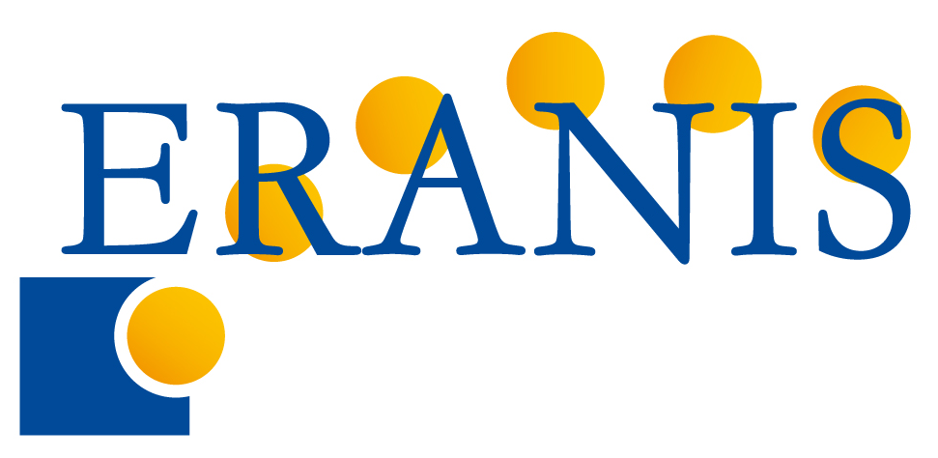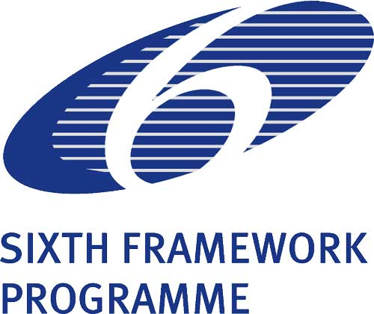
“GENERAL ISSUES ON FP7” - WORKSHOP PROGRAMME
(The first round of workshops within ERANIS Project)
Chisinau, Moldova
Date: 24 October 2007
Workshop conducted by Institute of Fundamental Research of The Polish Academy of Sciences (IPPT PAN) - ERANIS Project Coordinator
Str. Academiei, 5a, Biblioteca Ştiinţifică Centrală “Andrei Lupan”
The working language of the workshop will be English.
WORKSHOP PROGRAMME
Time | Presentation | Speaker
9:00 - 9:10 | Opening & Introduction | Representative of local NIS country organizer
9:10 - 10:00 | 6 Specific Programmes of FP7 | Krzysztof Trojanowski, IPPT PAN Expert
9:10 - 9:45  9:45 - 10:00 | - Cooperation, Ideas, People, Capacities, Euratom, JRC  - Third country specific rules
10:00 - 12:00 | How to participate in FP7 | Krzysztof Trojanowski, IPPT PAN Expert
10:00 - 10:45  10:45 - 12:00 | Work Programme & calls for proposals  Partner search facilities (CORDIS, Ideal-ist)
12:00-12:45 | Coffee Break
12:45 - 14:00 | Financial rules in FP7 | Barbara Trammer, IPPT PAN Expert
Grant Agreement and Consortium Agreement
Funding schemes; Financial regime ;Eligible costs
Maximum funding rates; Reporting and payments
Lump-sum financing for ICPC countries
14:00 - 14:30 | Practical aspects of participating in FP7 | Krzysztof Trojanowski, IPPT PAN Expert
14:00 - 14:15  14:15 - 14:30 | How and where to find a good coordinator  Possibilities offered by ERANIS Project | Krzysztof Trojanowski, IPPT PAN Expert  Representative of local ERANIS Partner
14:30 -15:00 | Questions & answers | All speakers of the workshop

