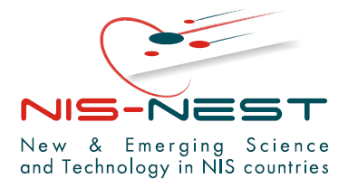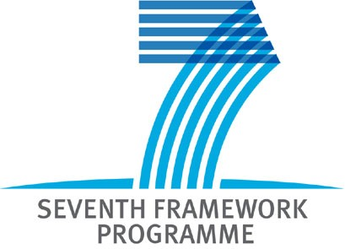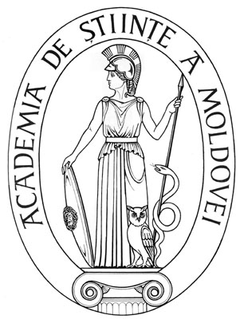
NIS-NEST Workshop on FP7 participation and proposal preparation
Chisinau, 5 October 2007
Organizer: Academy of Sciences of Moldova/ National Contact Point (NCP) in the Republic of Moldova for FP7
The event will take place within the framework of the NIS-NEST Project: Opening up the New and Emerging Science and Technology in Eastern European Countries
Draft Agenda
Morning Session: Friday, 5 October 2007 Participation in FP7
9:00-9:30 Registrations
9:30-10:00 Welcoming
The NIS-NEST project
Ms Maria Samara, Administrative Project Officer of the NIS-NEST project
10:00-11:00 The 7th Framework Programme and opportunities
for participation of Eastern European countries
Mr Paul Jamet, Coordinator of the National Contact Points for FP7 in France
11:00-12:00 FP7 rules of participation and legal issues
Ms Maria Samara, Administrative Project Officer of the NIS-NEST project
12:00-12:15 Questions and Discussion
12:15-12:45 Coffee Break
12:45-13:45 Questionnaire on rules of participation
All participants
13:45-14:30 Discussion
Afternoon Session: Friday, 5 October 2007 Proposal preparation in FP7
15:30-14:30 Writing a project proposal
    - Project idea
    - Consortium building- how to find partners
    - The structure of the proposal
    - Protecting your project idea- discussion and negotiation with the coordinator during proposal preparation
Mr Paul Jamet, Coordinator of the National Contact Points for FP7 in France
14:30-15:30 Writing a project proposal
    - Proposal submission
    - Proposal evaluation
    - Negotiations
    - What happens after proposal submission: project start and closure
Mr Paul Jamet, Coordinator of the National Contact Points for FP7 in France
14:30-15:30 FP7 financial issues
Ms Maria Samara, Administrative Project Officer of the NIS-NEST project
15:30-16:30 Exercise on financial issues
All participants
16:30 Discussion and closure of the workshop

